**Producer Consumer :**

**System Design**

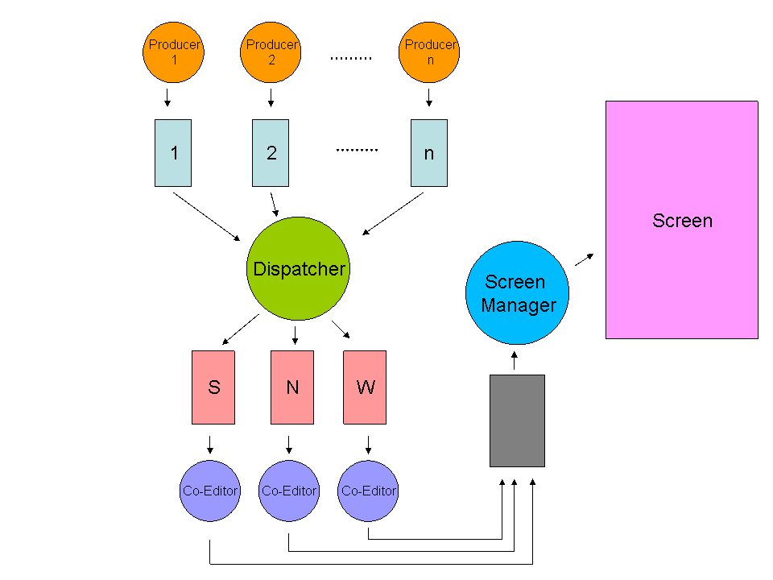

This program is a Producer-Consumer program that simulates a news production and distribution system. The program uses multiple producer threads, each with their own bounded queue for storing news, as well as three co-editor threads for sorting the news into different categories (sports, news, and weathers) and a single screen thread for displaying the news to the user.

The ReadFromFile function reads data from a specified file and creates a new producer for each set of data, with the producer's id, queue size, and number of news strings being set based on the data read from the file. The Produce function is used by each producer thread to generate and store a specified number of news strings in their own bounded queue.

The Dispatcher function is responsible for taking news strings from the producer's bounded queues and sorting them into the appropriate co-editor thread's unbounded queue based on the news category. The program uses a "DONE" message to signal the end of news production and to inform the co-editors and screen thread to stop processing.

The CoEditor and Screen functions are used by the co-editor and screen threads respectively, to process the news in their respective queues and display them to the user.

Ahigad Genish